

India Meteorological Department
Earth System Science Organisation
(Ministry of Earth Sciences)

BULLETIN NO. : 2 (ARB 04/2018)

TIME OF ISSUE: 2000 HOURS IST DATED: 06.10.2018

FROM: INDIA METEOROLOGICAL DEPARTMENT (FAX NO. 24643965/24699216/24623220)

TO: CONTROL ROOM, NDM, MINISTRY OF HOME AFFAIRS (FAX.NO. 23093750)
CONTROL ROOM NDMA (FAX.NO. 26701729)
CABINET SECRETARIAT (FAX.NO.23012284, 23018638)
PS TO HON’BLE MINISTER FOR S & T AND EARTH SCIENCES (FAX NO.23316745)
SECRETARY, MOES, (FAX NO. 24629777)
H.Q. (INTEGRATED DEFENCE STAFF AND CDS) (FAX NO. 23005137/23005147)
DIRECTOR GENERAL, DOORDARSHAN (23385843)
DIRECTOR GENERAL, AIR (23421105, 23421219)
PIB MOES (FAX NO. 23389042)
UNI (FAX NO. 23355841)
D.G. NATIONAL DISASTER RESPONSE FORCE (NDRF) (FAX NO. 24363261)
DIRECTOR, PUNCTUALITY, INDIAN RAILWAYS (FAX NO. 23388503)
CHIEF SECRETARY, TAMILNADU (FAX NO. 044-25672304)
CHIEF SECRETARY, KERALA (FAX NO. 0471-2327176)
ADMINISTRATOR, LAKSHADWEEP ISLANDS (FAX NO. 04896-262184)
ADMINISTRATOR, UNION TERRITORY OF DAMAN & DIU AND DADRA NAGAR HAVELI (0260-2230775)
CHIEF SECRETARY, KARNATAKA (FAX NO. 080-22258913)
CHIEF SECRETARY, GOA (FAX NO. 0832-2415201)
CHIEF SECRETARY, MAHARASHTRA (FAX NO. 022- 22028594)
CHIEF SECRETARY, GUJARAT (FAX NO. 079-23250305)

Sub: Depression over southeast & adjoining east-central Arabian Sea

The depression over southeast & adjoining eastcentral Arabian Sea slightly moved northwestward and lay centred at 1730 hrs IST of today, the 6th October 2018 near latitude 11.3°N and longitude 66.9°E, about 1500 km southeast of Salalah (Oman), 1400 km east-southeast of Socotra Islands (Yemen) and 750 km west-northwest of Minicoy (Lakshadweep Islands). It is very likely to intensify further into a Cyclonic Storm during next 24 hours. It is very likely to move northwestwards towards South Oman & adjoining Yemen Coasts during next 5 days.

Warnings:

- Heavy rainfall warning for Tamil Nadu & Puducherry, Kerala and Lakshadweep in association with cyclonic storm and easterly wave.
Sub-Divisions | 06 Oct. 2018 * | 07 Oct. 2018 * | 08 Oct. 2018* | 09 Oct. 2018*
Kerala | Rainfall at most places with heavy to very heavy falls at Isolated Places | Rainfall at most places with heavy to very heavy falls at Isolated Places | Rainfall at most places with heavy to very heavy falls at Isolated Places | Rainfall at many places with heavy falls at Isolated Places
Tamilnadu & Puducherry | Rainfall at most places with heavy to very heavy falls at Isolated Places | Rainfall at most places with heavy to very heavy falls at Isolated Places | Rainfall at most places with heavy to very heavy falls at Isolated Places | Rainfall at many places with heavy falls at Isolated Places
Lakshadweep Islands | Rainfall at most places with heavy to very heavy falls at Isolated places | Rainfall at most places with heavy to very heavy falls at Isolated places | Rainfall at most places | Rainfall at a few places
Note: * Rainfall till 0830 IST of next day.
Legends: Orange- Be prepared; Yellow- be updated, Green: No warning
Heavy rain: 64.5-115.5 mm/day; Very heavy rain: 115.6-204.4 mm/day; Extremely heavy rain: more than 204.4 mm/day
- Wind warning
- Squally wind speed reaching 40-50 kmph gusting to 60 kmph very likely over Lakshadweep and southeast Arabian Sea on 6th and 7th October.
- Squally wind speed reaching 40-50 kmph gusting to 60 kmph very likely over central Arabian Sea on 6th. The wind speed will gradually increase becoming 60-70 kmph gusting to 80 kmph on 8th October 2018. It will also increase thereafter.
- Sea condition
- The sea condition would become rough to very rough from today the 6th October over southeast Arabian Sea and adjoining central Arabian Sea. It will become gradually high over central Arabian Sea around system centre from 7th evening/ 8th morning.
- Fishermen Warning
- The fishermen are advised not to venture into deep sea areas of southeast and Lakshadweep area during 6th and 7th October and into east central Arabian Sea from 6th to 9th October and west-central Arabian Sea from 8-11 October.
- The fishermen out at deep Sea are advised to return to coast.
The next bulletin will be issued at 0230 hrs IST of 07th October, 2018.

(D. R. Pattanaik)
Scientist-E, RSMC, New Delhi

Copy to: CRS, Pune/ ACWC Chennai/ Mumbai/MC Goa/Thiruvanathapuram/ Bengaluru/ CWC Ahmedabad.

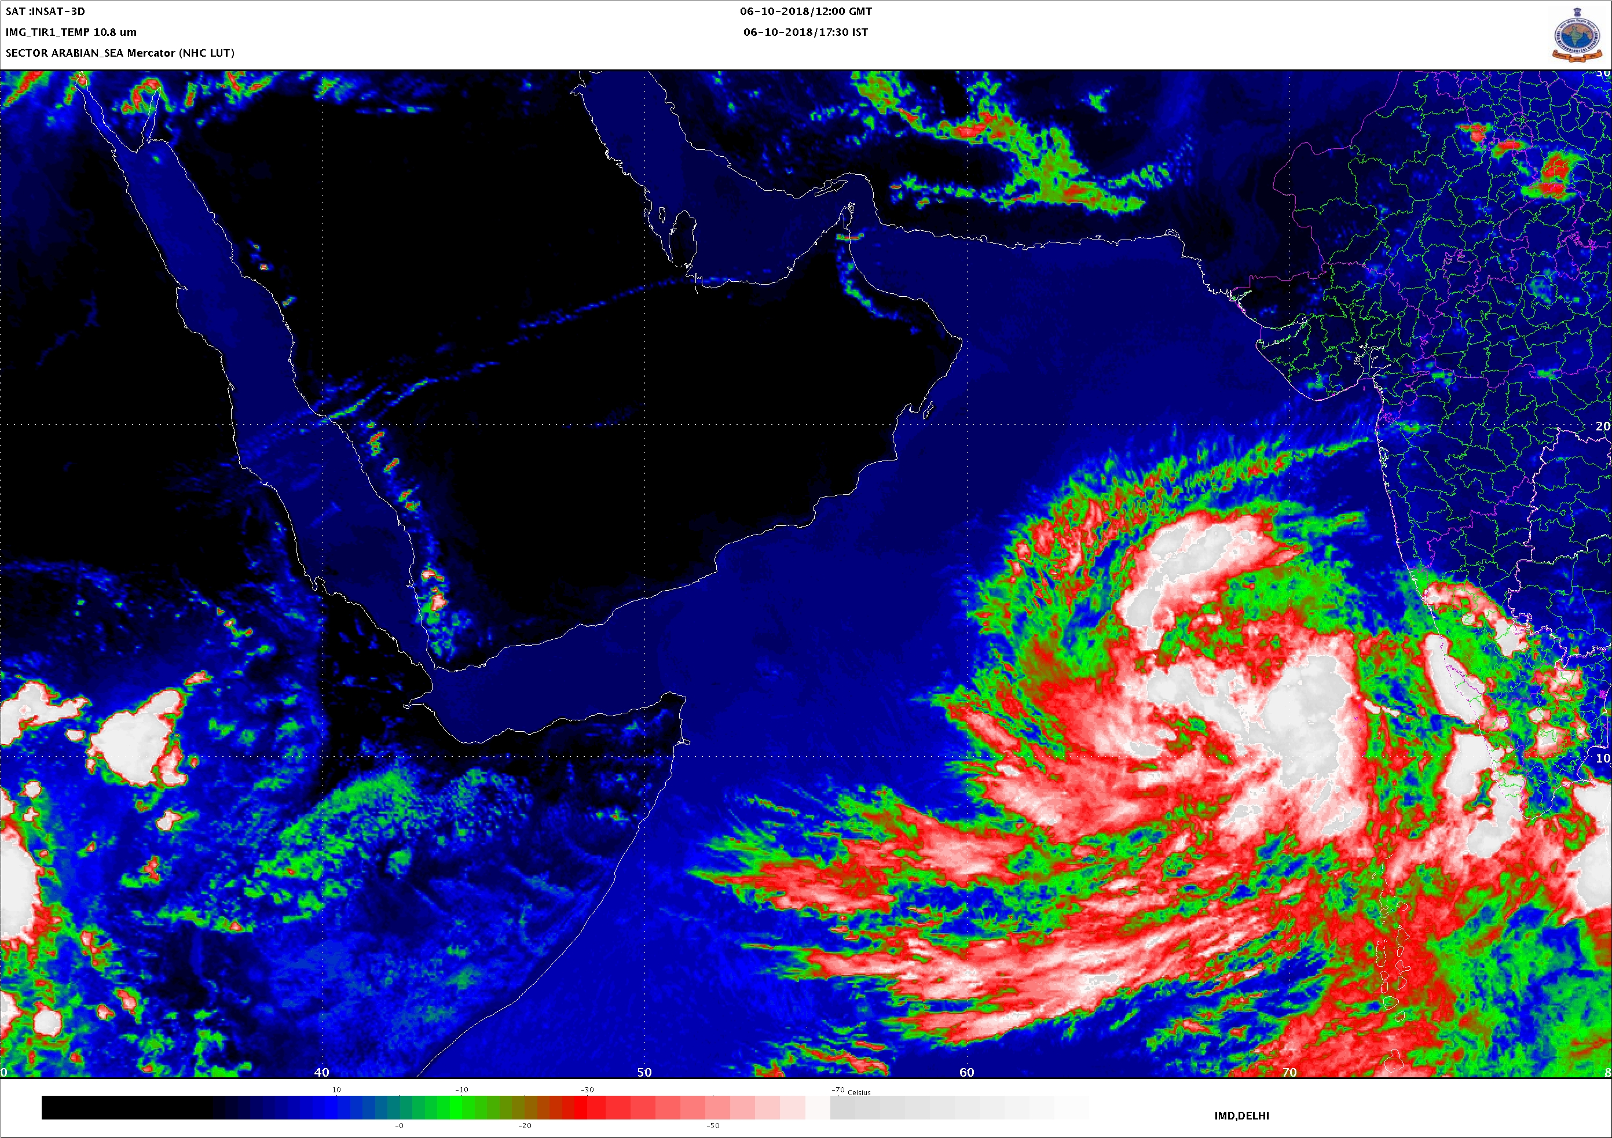
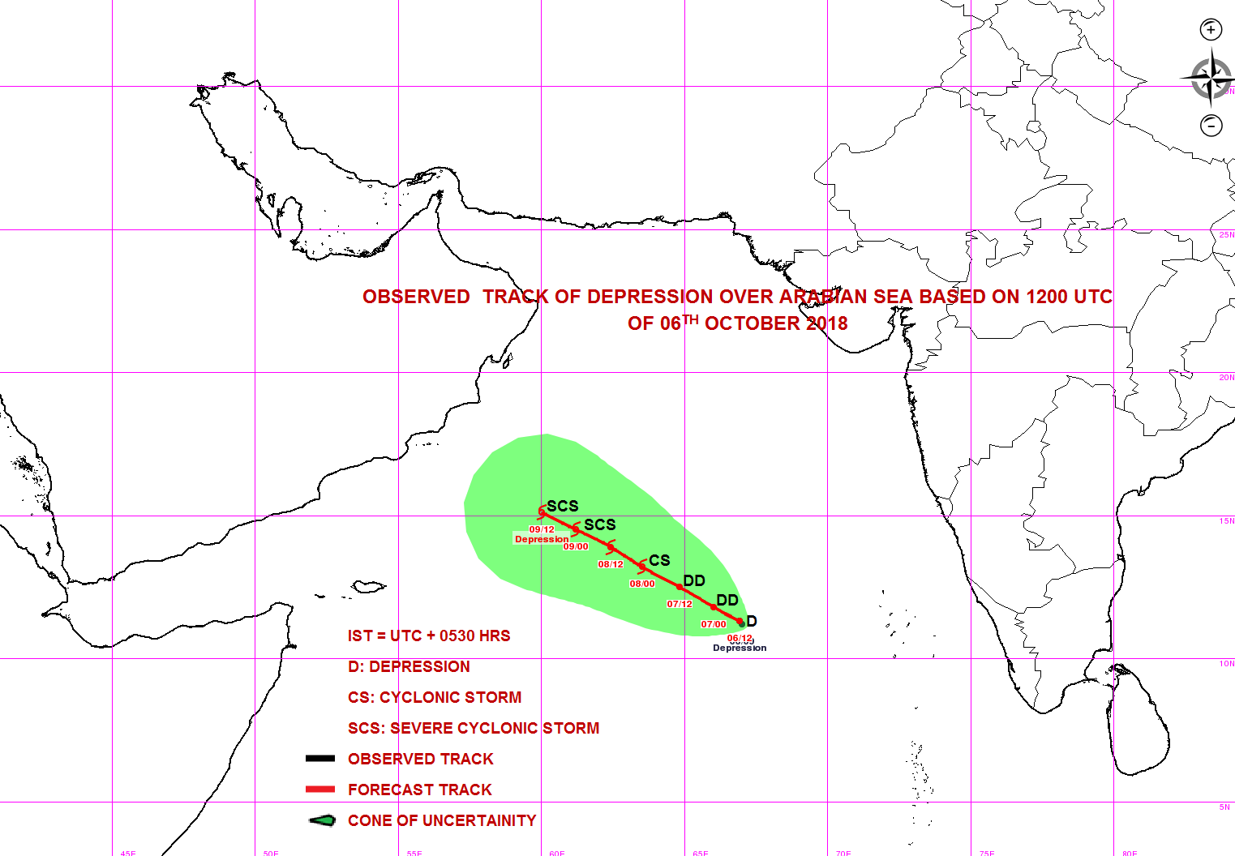
NORTHWEST
ARABIAN
WESTCENTRAL ARABIAN
EASTCENTRAL ARABIAN
SOUTHWEST ARABIAN SEA
SOUTHEAST ARABIAN SEA
NORTHEAST
ARABIAN
Depression (11.3°N, 66.9°E)

